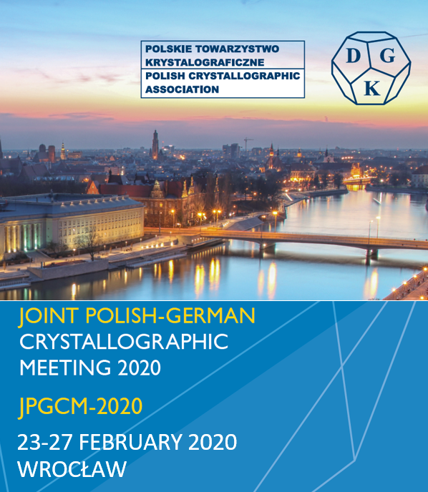

Joint Polish-German Crystallographic Meeting 2020
23 - 27 February 2020 • Wrocław/Poland

Venue
Congress Center Wrocław University of Science and Technology
Building D20
ul. Janiszewskiego 8 (Janiszewskiego St. 8)
50-372, Wrocław, Poland

Date
23 - 27 February 2020

Organizer
German Crystallographic Society (DGK)
Polish Crystallographic Association (PCA)

Conference chairs
Prof. Dr. hab. inż. Marek Główka Łódź University of Technology (Łódź/PL)
Prof. Dr. hab. Marek Wołcyrz Polish Academy of Sciences (Wrocław/PL)
Prof. Dr. Susan Schorr Helmholtz-Zentrum Berlin (Berlin/DE)
Prof. Dr. Udo Heinemann Max-Delbrück-Center for Molecular Medicine (Berlin/DE)

International programme committee
Prof. Dr. rer. nat. habil. Robert Dinnebier (Stuttgart/DE)
Prof. Dr. rer. nat. Thomas Doert (Dresden/DE)
Priv.-Doz. Dr. Claudia Weidenthaler (Mülheim an der Ruhr/DE)
Jan Philipp Wöhrle (Freiburg i. Br./DE)
Prof. Dr. Matthias Bochtler (Warsaw/PL)
Prof. Dr. hab. Mariusz Jaskólski (Poznań/PL)
Prof. Dr. hab. Ilona Turowska-Tyrk (Wrocław/PL)
Prof. Dr. hab. Krzysztof Woźniak (Warsaw/PL)

The official conference language is English.

Professional congress organiser
Conventus Congressmanagement & Marketing GmbH
Anja Hannawald
Carl-Pulfrich-Straße 1
07745 Jena, Germany
Phone +49 3641 31 16-327
Fax +49 3641 31 16-243

Registration fees
Until 31 December 2019 from 1 January 2020
Member DGK 185 EUR 225 EUR
Non-member 225 EUR 265 EUR
Student 95 EUR 105 EUR

Participants from Poland

All 120 EUR 120 EUR
Student/PhD stud. 60 EUR 60 EUR

Abstract book 20 EUR 20 EUR

Welcome reception 0 EUR 0 EUR
Conference dinner 45 EUR 45 EUR

Payment and confirmation of payment
An invoice or confirmation of registration will be sent to you via e-mail within 14 days after online registration. This invoice is a valid invoice which may be submitted to the local tax and revenue office. All fees are due upon receipt of invoice/registration confirmation. Only after successful payment you are registered and can take part in the conference. Payment transfers must include participant’s name and invoice number. Payment is also accepted by credit card (Master-/Eurocard, American Express, VISA). In case you have transferred the registration fee shortly before the start of the conference, (up to 10 days prior to conference opening), we ask you to please present your transfer remittance slip onsite.

Conventus Congressmanagement & Marketing GmbH
Carl-Pulfrich-Straße 1
07745 Jena Germany
telephone +49 3641 31 16-160
fax +49 3641 31 16-244
www.conventus.de

Bank account:
Hypo Vereinsbank
IBAN DE66 8302 0087 0326 5082 41
BIC/SWIFT-Code HYVEDEMM463

Meeting’s web-site: https://www.dgk-conference.de

